 | Description | Qty | Unit | Rate  ( RM ) | Amount  ( RM )
1 | Concealed Ceiling with Gyproc Moisture Resistant Boards  To supply and install Concealed Ceiling comprising of single layer Gyproc 9mm Moisture Resistant board size: 1220mm x 2440mm staggered screw-fixed not exceeding 200mm centres onto SteelMax Lightweight Secondary Channel “SLC2900” (BMT=0.32mm, Galvanised Steel) spaced at 406mm centres that are locked onto SteelMax Lightweight Main runner “SLM2900” (BMT=0.6mm, Galvanised Steel) spaced at 1200mm centres. The Main channels”SLM2900” are held to ceiling with Suspension Threaded Rod ¼” in diameter(length not exceeding 2m) which are fixed onto the soffit using ¼” drop in anchor at 900mm centres; including SteelMax Perimeter “SLP2440” suspension to finished with SteelMax Secondary Channel “SLC2900”  All boards joints secure with Gyproc Paper Tape and finished with Protop  Joint Compound for a seamless finish. All fixing accessories, additional nogging for services installation as per manufacturer details  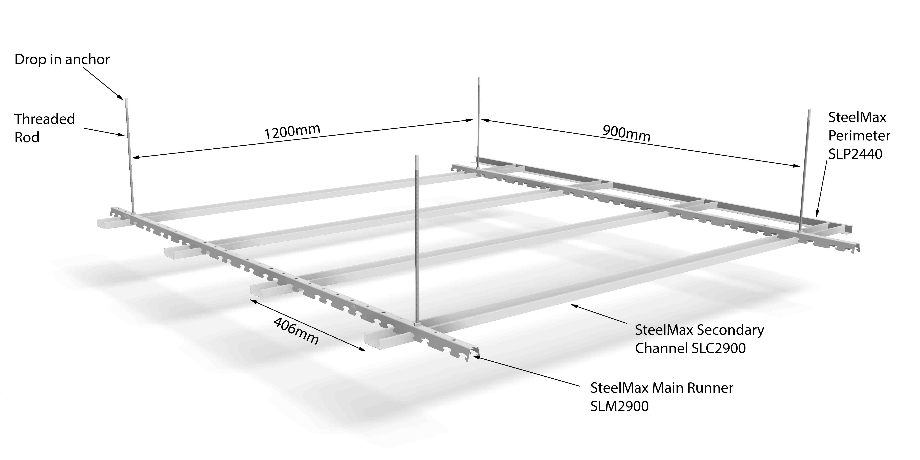 | Rate | M²
 | GRAND TOTAL

